Review of Literature (Research Essay)
Criteria
- 2-3 pages typed (minimum)
- 12 font (Times new roman or Helvetica)
- 1 inch margins

What Is a Review of Literature?
The short answer is that the Review of Literature is a report summarizing the answers to the research questions you generated in the previous assignment. It's a review of the relevant "literature" (books, magazines, Web sites) discussing the topic you want to investigate.
The long answer is that the Review of Literature discusses techniques and equipment that are appropriate for investigating your topic. And, the Review of Literature summarizes the theory behind your experiment. Science fair judges like to see that you understand why your experiment turns out the way it does. You do library and Internet research so that you can make a prediction of what will occur in your experiment, and then whether that prediction is right or wrong, you will have the knowledge to understand what caused the behavior you observed.
If this sounds to you a lot like the reasons we gave for doing background research, you're right! The Review of Literature is simply the "write up" of that research.
Many science experiments can be explained using mathematics. As you write your Review of Literature, you'll want to make sure that you include as much relevant math as you understand. If a simple equation describes aspects of your project area, include it.

Sample Review of Literature: http://www.sciencebuddies.org/science-fair-projects/project_sample_review_of_lit.shtml

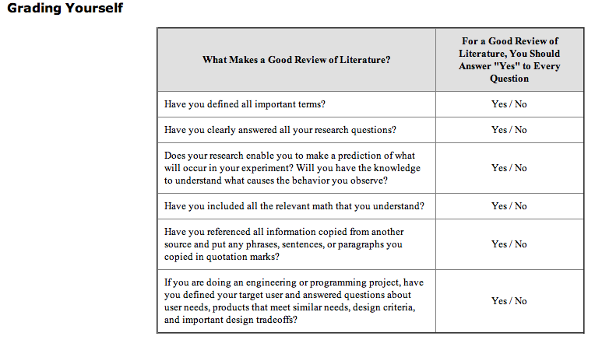
Format For Review of Literature:
Introduction: Introduce overarching question and how it relates to real world
Body Paragraph #1: Answering research Question #1
Body Paragraph #2: Answering research Question #2
Body Paragraph #3: Answering research Question #3
Body Paragraph #4: Answering research Question #4
Body Paragraph #5: Answering research Question #5
Conclusion: Relating the Research Question Paragraphs: Make connections between ideas discussed in body paragraphs.

